NOVEMBER DEALS!

--------------------------------------------------------------------------------------------------------
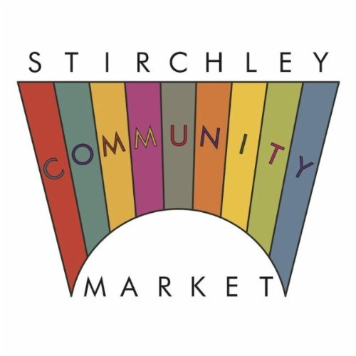
Buy-One-Get-One-Free on Harry Starling Prints

Present this voucher at Harry’s stall to redeem the offer.

Cheapest print free, only valid at November’s Stirchley Community Market

-------------------------------------------------------------------------------------------------------

And remember, if you buy a Stirchley Community Market mug and show it to Tom Baker on the Loaf stall outside you’ll qualify for a half-price ciabatta (while stocks last).

